EXPT NO:6A | DATA VISUALIZATION USING POWER BI (RETAIL SALES ANALYSIS)

AIM:
To import, transform, analyze, and visualize the Retail Sales dataset using Power BI Desktop and create an interactive dashboard and reports for decision-making.
ALGORITHM:
- Start the Power BI Desktop application.
- Import the Retail Sales dataset (Retail_Sales_Raw) into Power BI using Get Data → Excel.
- Load the dataset into Power BI.
- Check the columns – OrderID, OrderDate, CustomerName, Region, ProductCategory, Product, Quantity, UnitPrice, Discount and TotalSales – and clean the data using Power Query if required.
- Remove duplicate records and handle missing values.
- Create required calculated fields/measures such as Total Sales, Average Sales, Total Orders and Total Quantity.
- Create a bar chart to compare category-wise sales.
- Create a pie chart to display category-wise sales contribution.
- Create a line chart to represent the monthly sales trend.
- Create card visuals to display important summary values.
- Add suitable titles, labels, filters, and slicers.
- Arrange the visuals into a Power BI dashboard.
- Analyze the visualizations and identify important patterns.
- Save the Power BI report.
- Stop.
OUTPUT:
Retail Sales dataset loaded into Power BI (Data View):
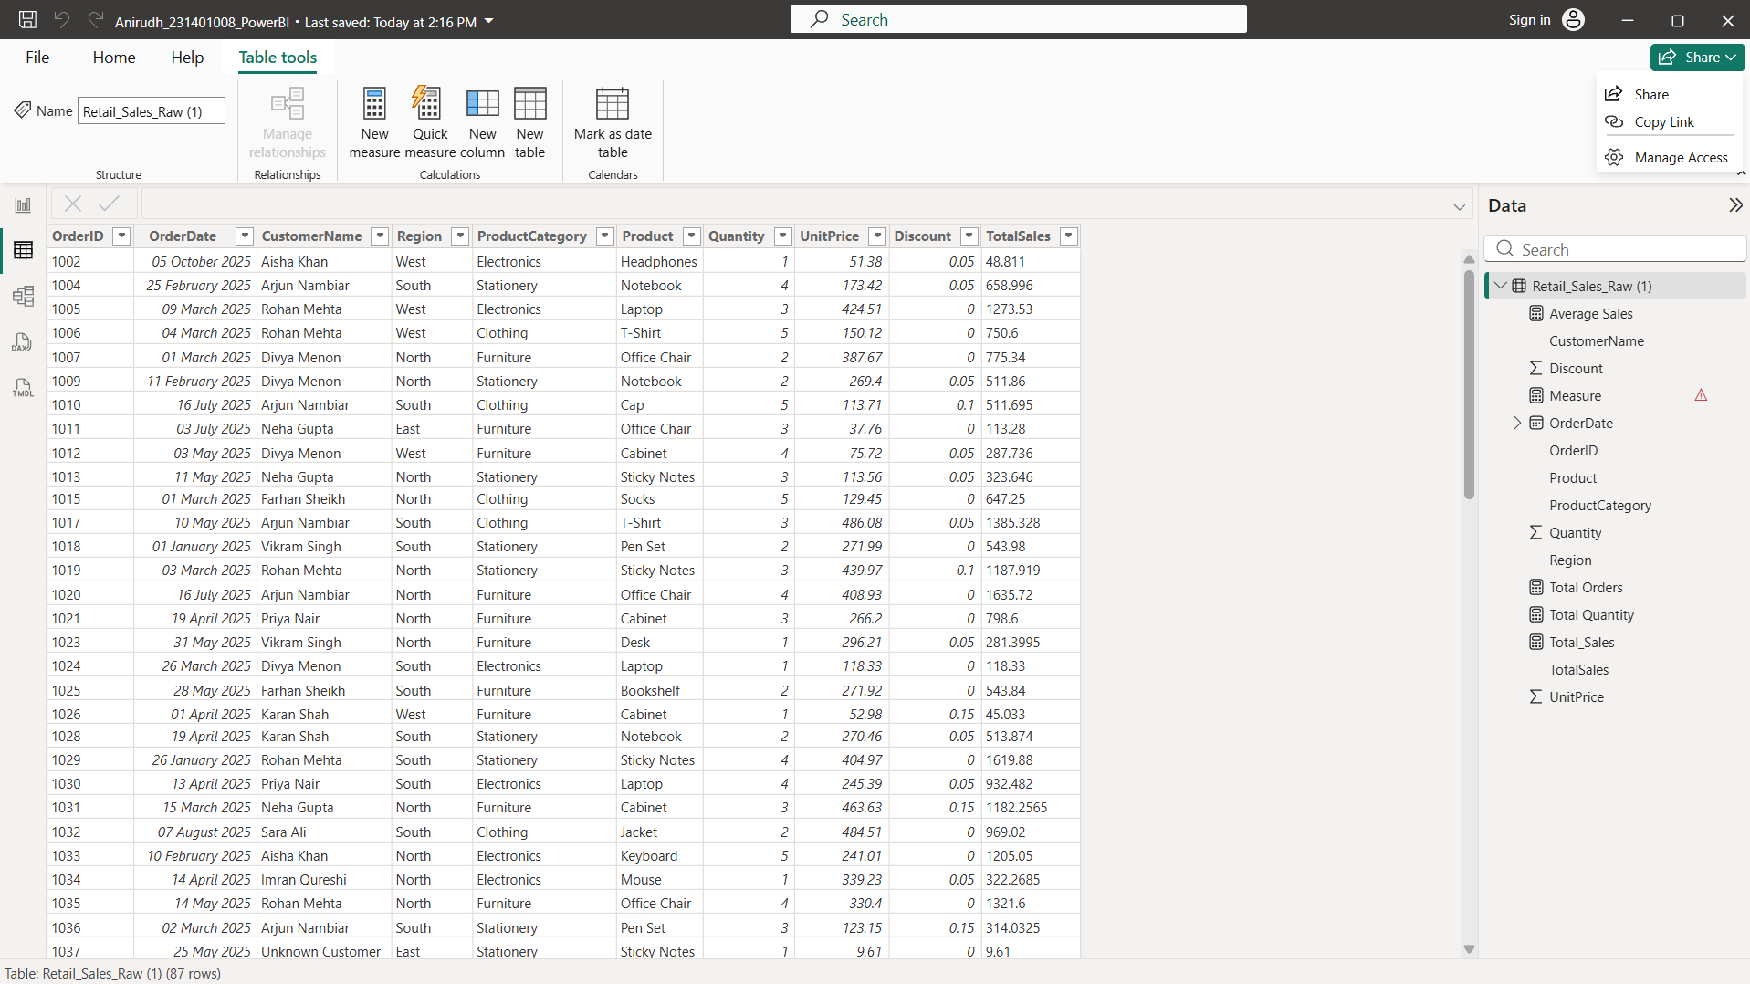
Verifying the dataset using DAX Query View:
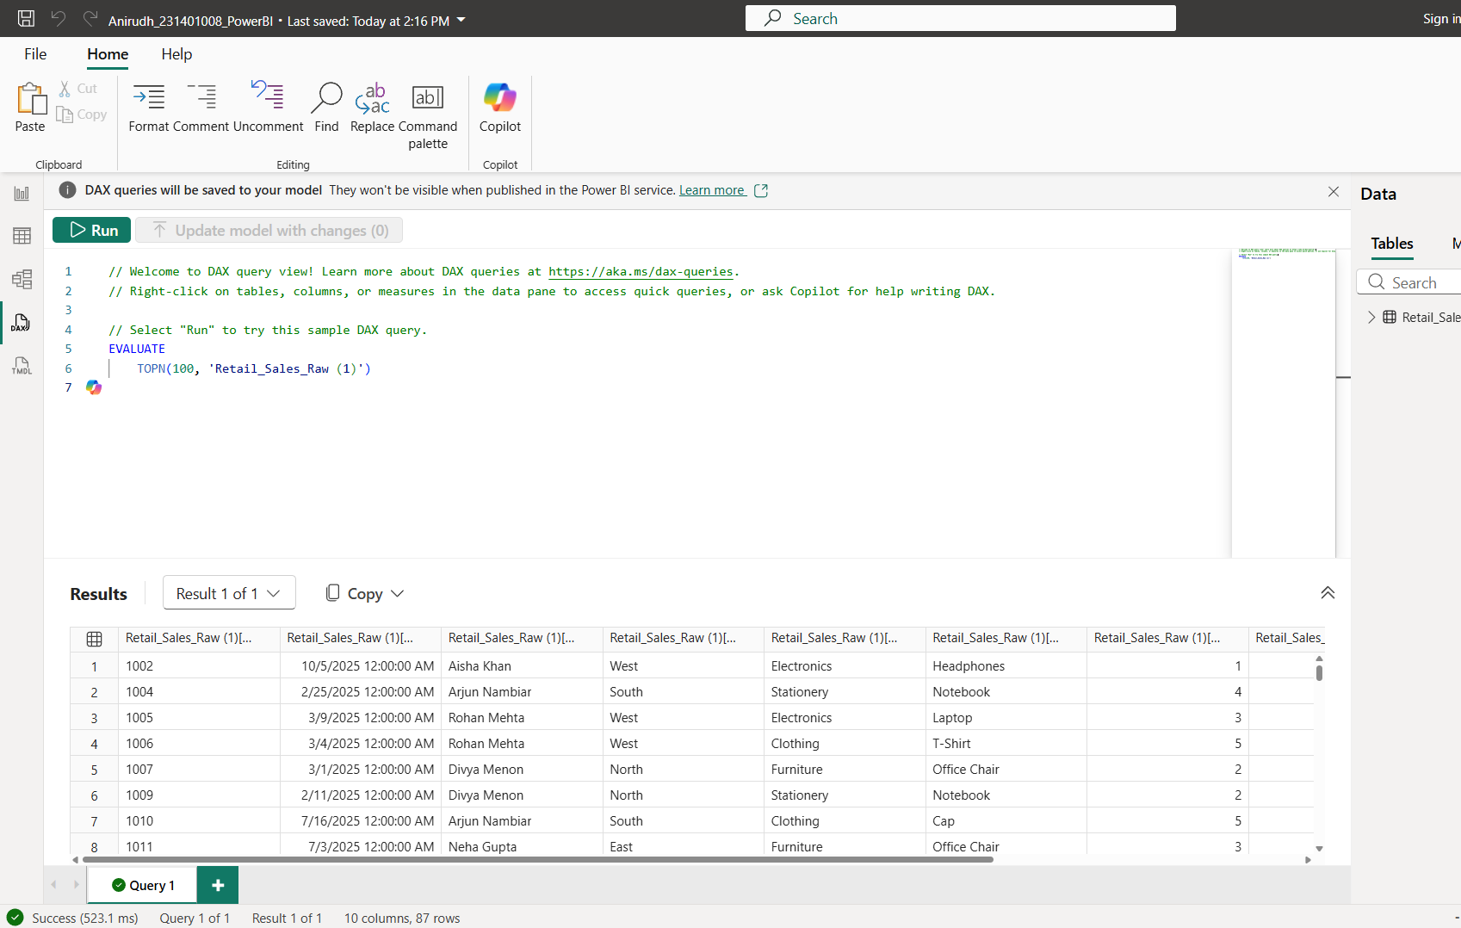
Creating a Bar Chart – Category-wise Sales
Sales comparison across product categories.
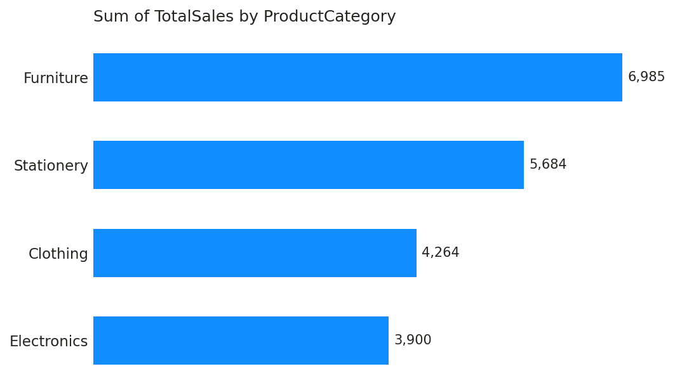
Creating a Pie Chart – Sales Contribution by Category
Percentage contribution of each product category.
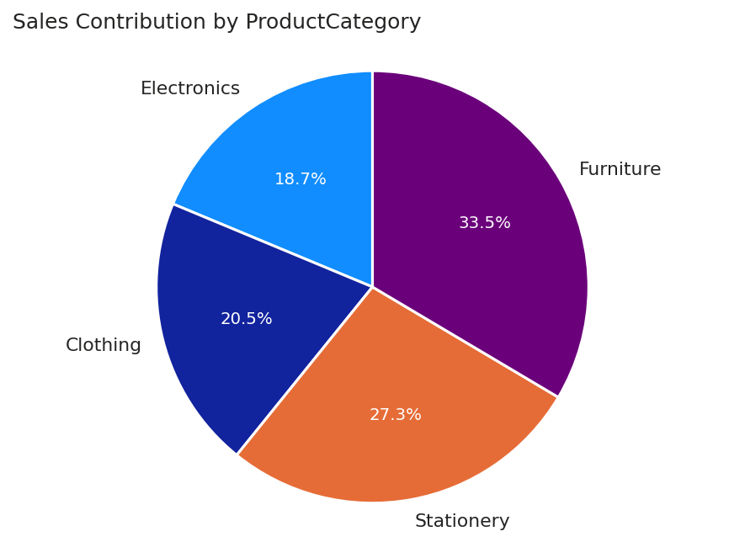
Creating a Line Chart – Monthly Sales Trend
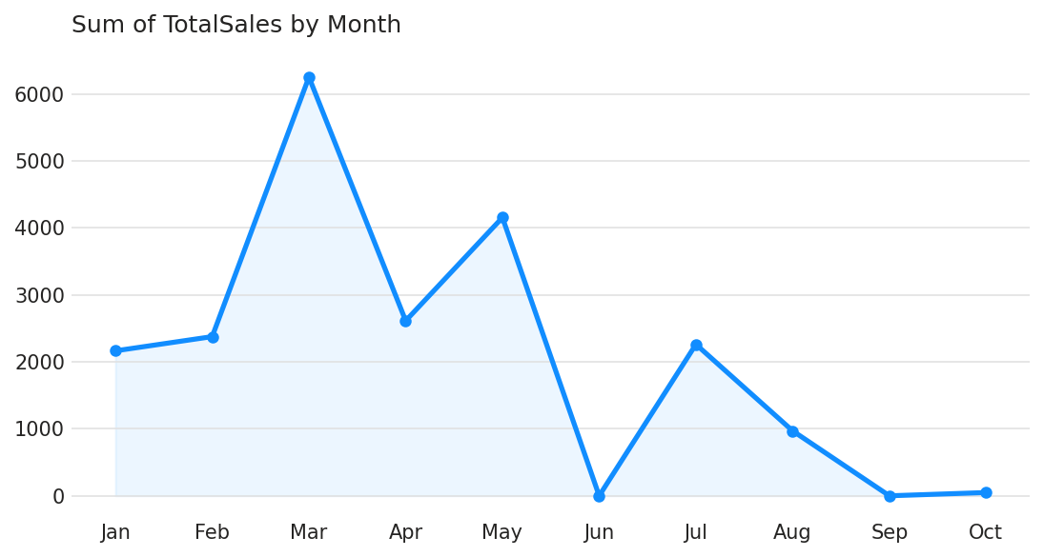
Creating KPI Cards:
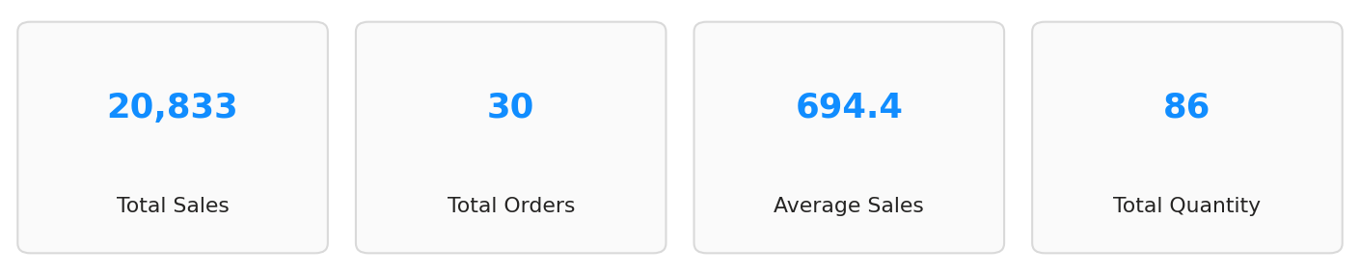
Creating Slicers:
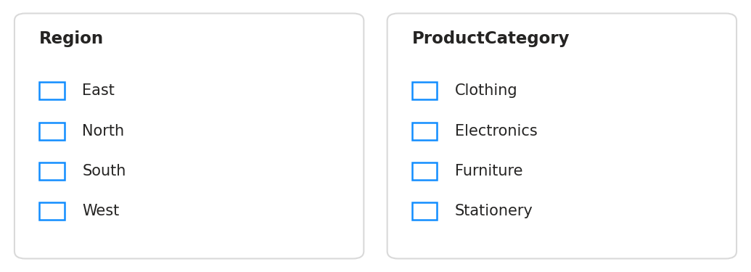
Creating Dashboard:
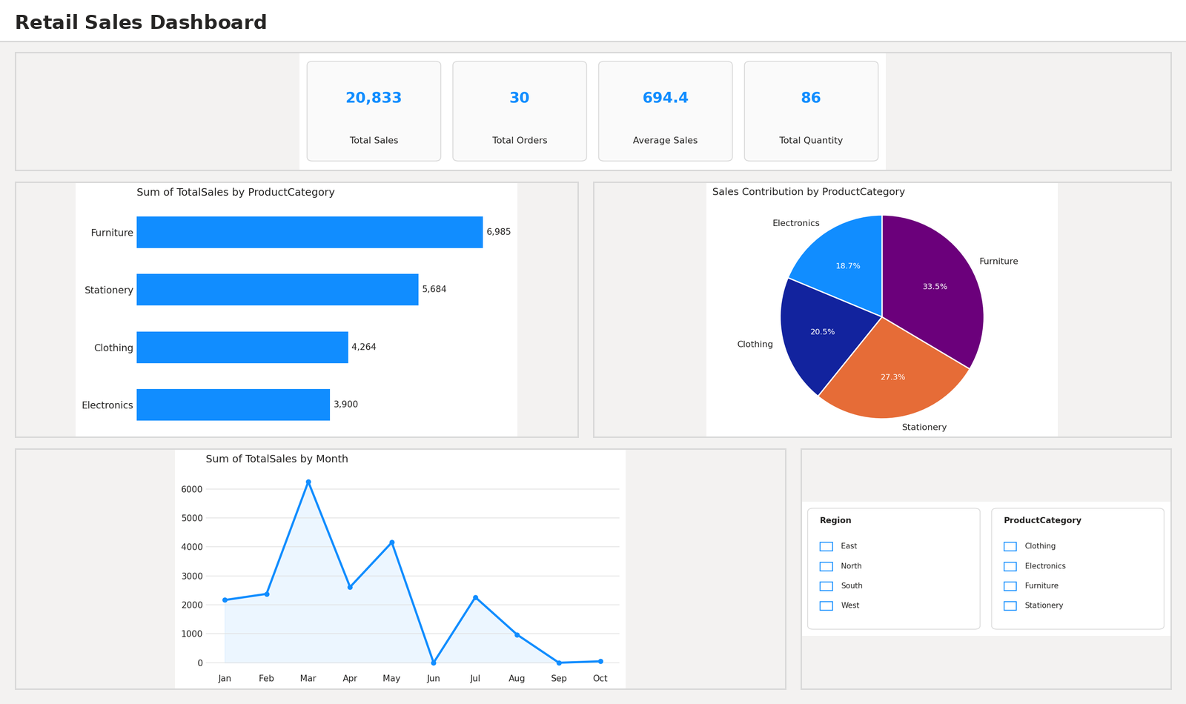
RESULT:
Thus, the Retail Sales dataset was successfully imported, cleaned, transformed, and visualized using Power BI Desktop, and an interactive dashboard was created to analyze sales performance across product categories, regions, and time periods.

EXPT NO:6B | DATA VISUALIZATION USING POWER BI (RETAIL SALES – ADVANCED ANALYTICS)

AIM:
To load the Retail Sales dataset into Power BI, transform and clean the data using Power Query, create advanced DAX measures, and develop statistical visualizations to analyze pricing, discount patterns, and customer-level sales performance.
ALGORITHM:
ALGORITHM 1: IMPORTING DATA INTO POWER BI
Step 1
Open Power BI Desktop.
Step 2
Select Home → Get Data.
Step 3
Choose Excel Workbook.
Step 4
Browse and select the Retail Sales dataset (Retail_Sales_Raw.xlsx).
Step 5
Click Load to import the dataset.
Step 6
Verify the imported columns and records in the Data View.
ALGORITHM 2: DATA TRANSFORMATION USING POWER QUERY
Step 1
Select Transform Data.
Step 2
Open the Power Query Editor.
Step 3
Assign appropriate data types to OrderDate, Quantity, UnitPrice, Discount and TotalSales.
Step 4
Remove duplicate records based on OrderID.
Step 5
Handle missing or null values in Region, ProductCategory and CustomerName.
Step 6
Standardize categorical values such as Region and ProductCategory.
Step 7
Click Close & Apply to load the transformed dataset into Power BI.
ALGORITHM 3: CREATING ADVANCED DAX MEASURES
Step 1
Right-click the table name → select New Measure.
Step 2
Define Total Sales = SUM(Retail_Sales_Raw[TotalSales]).
Step 3
Define Average Discount = AVERAGE(Retail_Sales_Raw[Discount]).
Step 4
Define Total Orders = COUNTROWS(Retail_Sales_Raw).
Step 5
Define Top Category Sales using CALCULATE and TOPN to identify the best-selling product category.
ALGORITHM 4: STATISTICAL VISUALIZATION
Step 1
Select a Scatter Chart and map Quantity to the X-axis and UnitPrice to the Y-axis, with ProductCategory as the legend, to study the price–quantity relationship.
Step 2
Select a Bar Chart to identify the Top 5 Customers by Sales.
Step 3
Select a Column Chart to display the Order Count by Discount Level.
Step 4
Add suitable titles, legends, and formatting to the visuals.
ALGORITHM 5: DASHBOARD VISUALIZATION & REPORTING
Step 1
Arrange all the visuals into a single Advanced Analytics dashboard page.
Step 2
Add slicers and cross-filtering for ProductCategory and Region.
Step 3
Analyze the dashboard to identify pricing trends, discount patterns, and top customers.
Step 4
Save the Power BI report.
OUTPUT:
Creating DAX Measures:
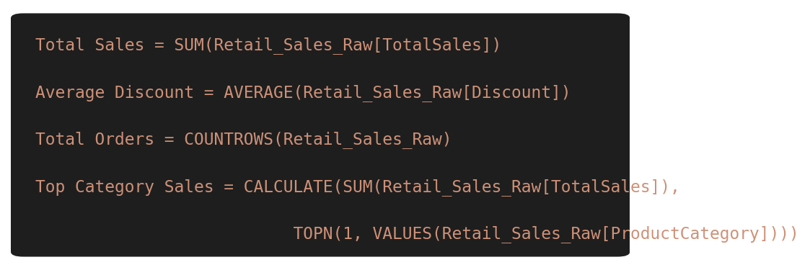
Creating a Scatter Chart – UnitPrice vs Quantity by Category
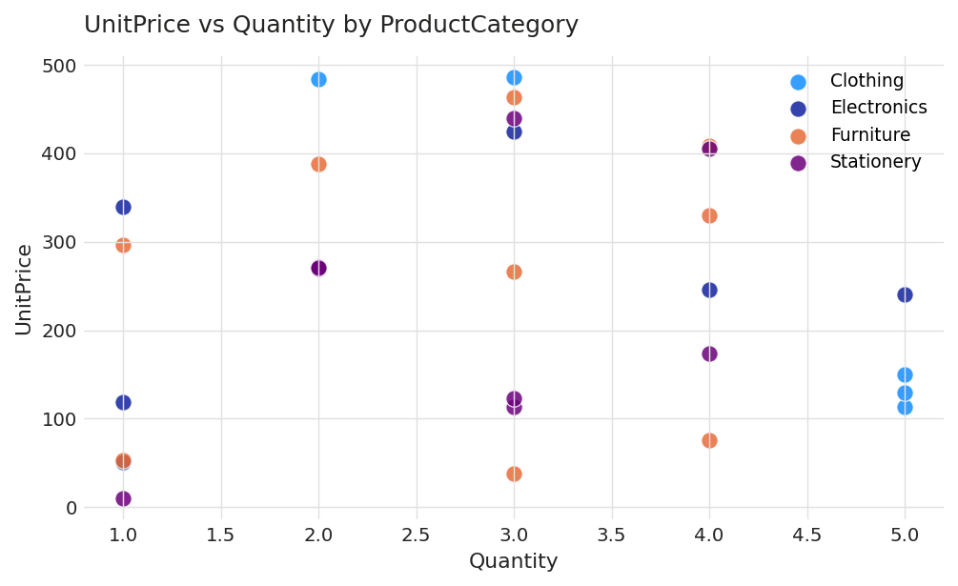
Creating a Bar Chart – Top 5 Customers by Sales
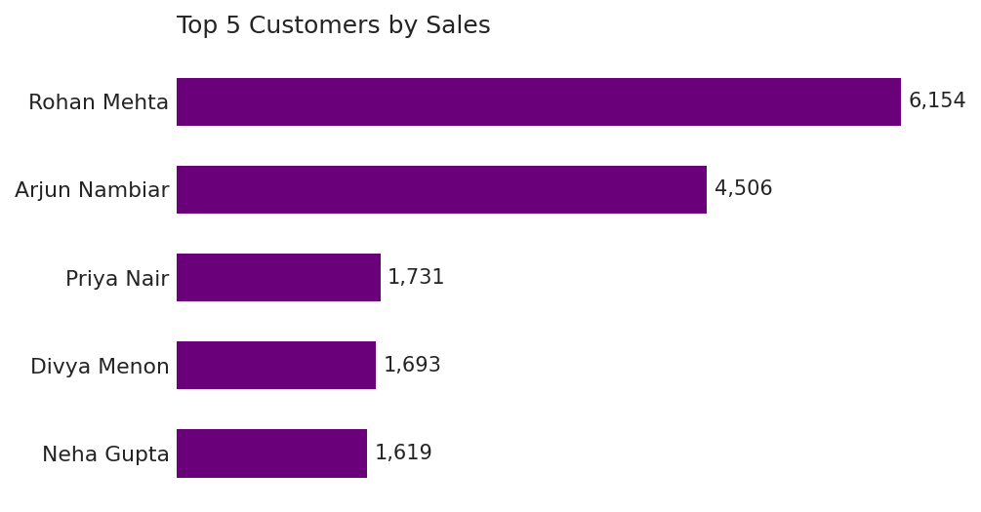
Creating a Column Chart – Order Count by Discount Level
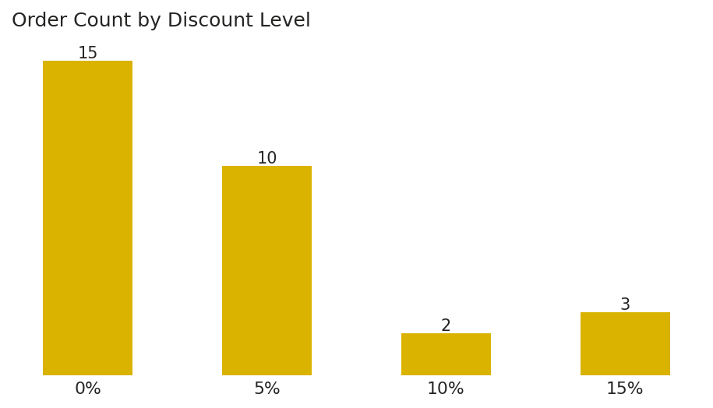
Creating Advanced Analytics Dashboard:
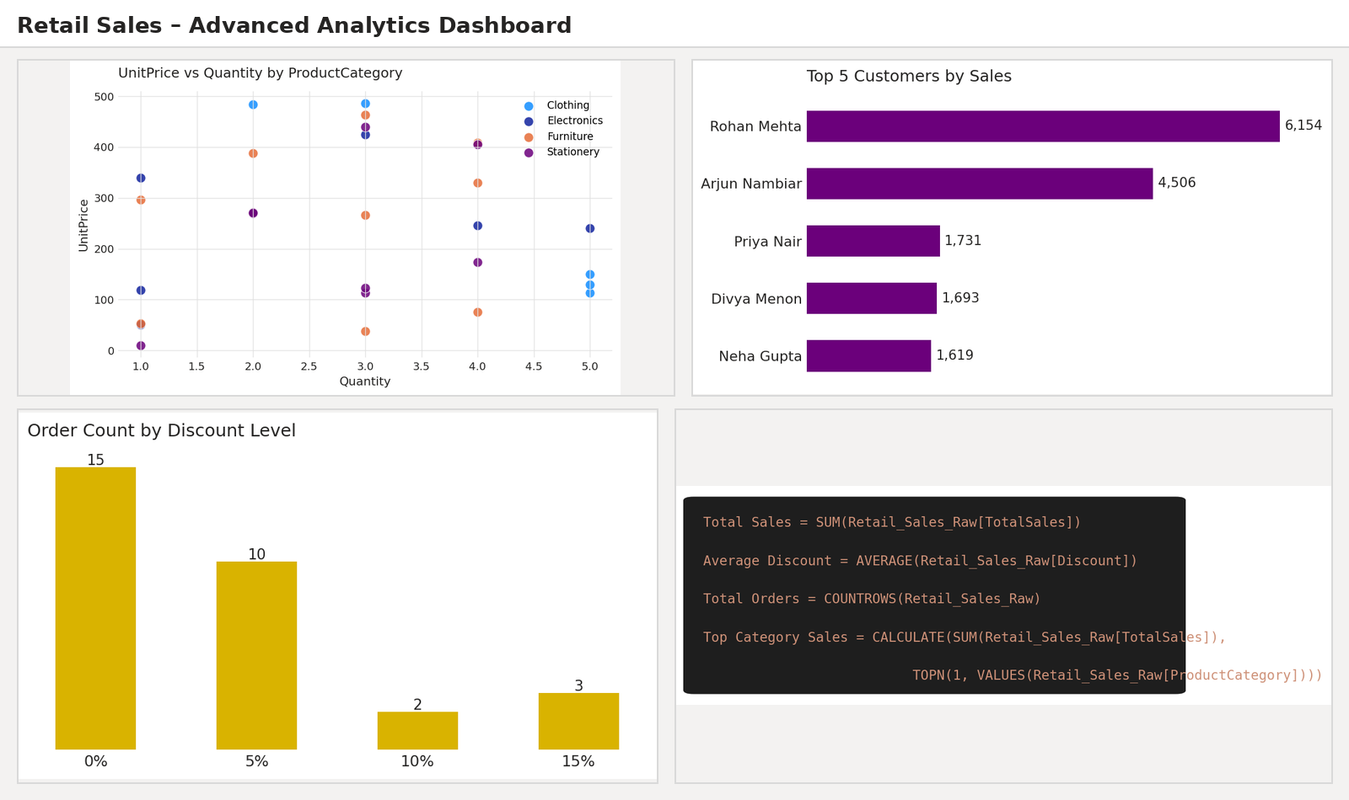
RESULT:
Thus, advanced DAX measures were created and statistical visualizations were built using Power BI Desktop to analyze pricing patterns, discount distribution, and top customer contribution within the Retail Sales dataset.

EXPT NO:6C | DATA VISUALIZATION USING POWER BI (RETAIL SALES – REGIONAL & CUSTOMER INSIGHTS)

AIM:
To clean, preprocess, and transform the raw Retail Sales dataset, load the cleaned data model into Power BI, and build an interactive dashboard to analyze regional performance and customer-wise sales contribution.
ALGORITHM:
- Import Dataset: Load Retail_Sales_Raw.xlsx into Power BI using Get Data → Excel.
- Deduplication: Identify and remove duplicate records based on OrderID.
- Handle Missing/Unknown Values: Replace “Unknown Customer” entries in CustomerName with “Guest Customer” and impute missing Discount values with 0.
- Handle Data Type & Syntax Errors: Format OrderDate as Date, Quantity as Whole Number, and UnitPrice, Discount and TotalSales as Decimal.
- Load Clean Data: Load the cleaned table into Power BI Desktop via Get Data → Excel (or Close & Apply from the Power Query Editor).
- Create Core Measures: Total Revenue = SUM(TotalSales); Total Customers = DISTINCTCOUNT(CustomerName).
- Create a column chart to analyze the Sum of TotalSales by Region.
- Create a bar chart to analyze the Sum of TotalSales by Customer.
- Add card visuals for Total Revenue, Total Customers, Regions Covered and Average Order Value.
- Arrange the visuals into a Regional & Customer Insights dashboard.
- Save the Power BI report.
OUTPUT:
Data Cleaning Summary:
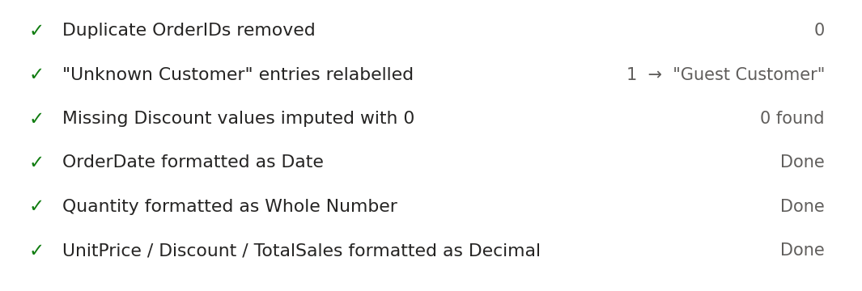
Creating KPI Cards:
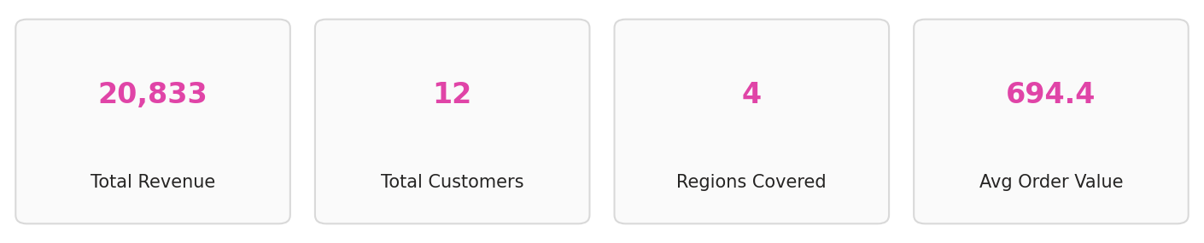
Creating a Column Chart – Sum of TotalSales by Region
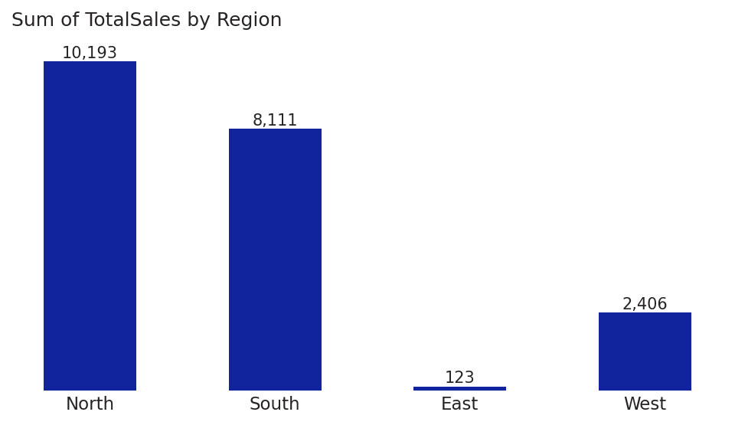
Creating a Bar Chart – Sum of TotalSales by Customer
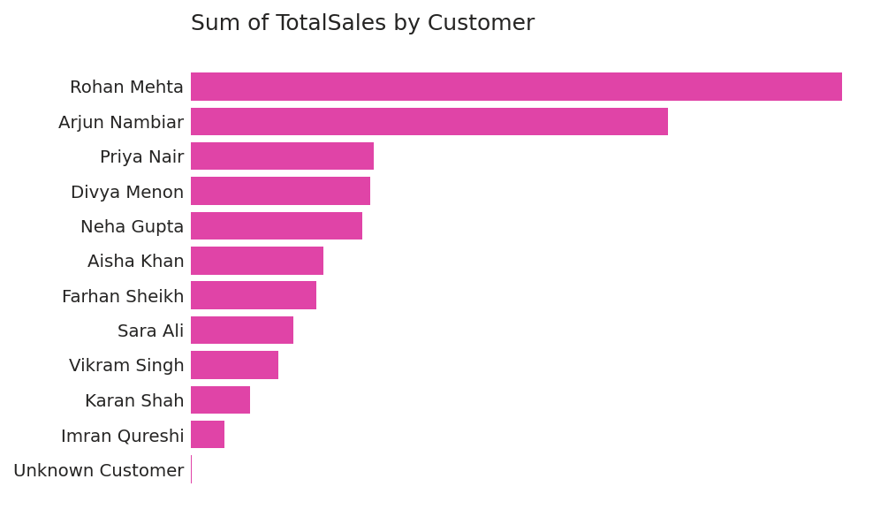
Creating Regional & Customer Insights Dashboard:
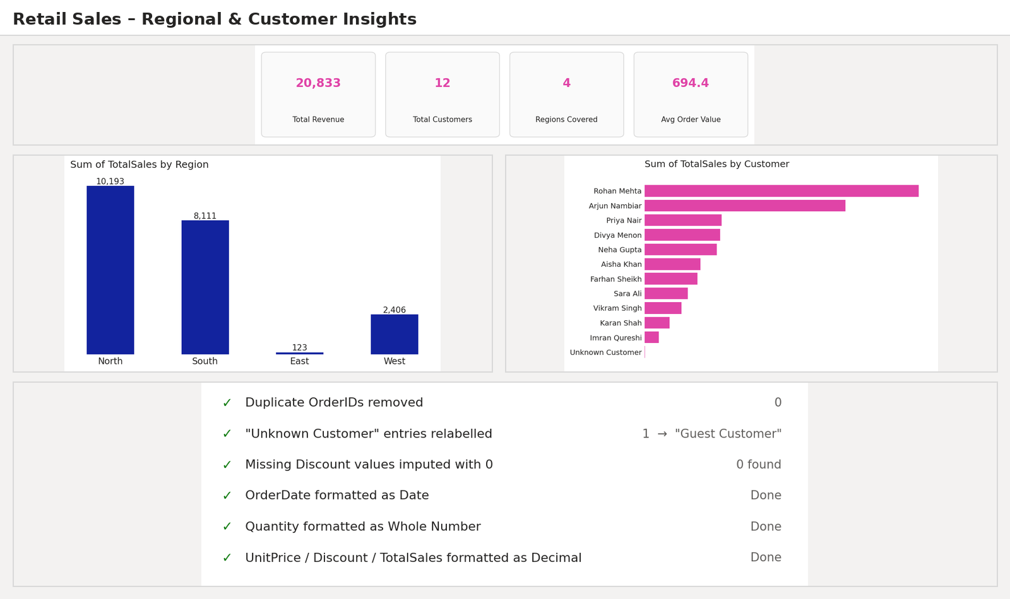
RESULT:
Thus, the Retail Sales dataset was successfully cleaned, transformed, and loaded into Power BI Desktop, and an interactive dashboard was created to analyze regional performance and customer-wise sales contribution.

